Cape Reptile Club | 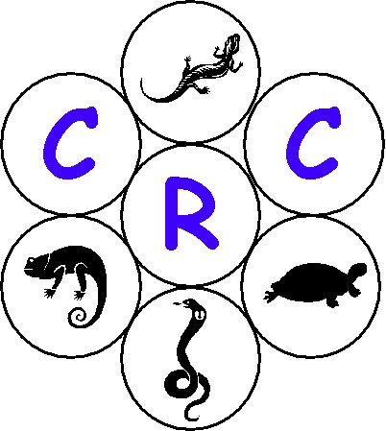
General Meeting – 2005/05/27 (Pinehurst Jnr School, Pinelands)

- Opening & Welcome

Deon opened the meeting and welcomed all present.

- Amendment to the previous minutes

There where no amendments mentioned to the minutes dated 2005/04/15.

- Introduction and overview

Deon discussed and addressed the following items:

- He requested that all cell phones to be switched off unless it needs to be left on in case of an emergency.

- He went on and said that Alan has done a tremendous amount of work on the web and encourage all to go to the CRC’s web site. The web address is as follows: http://www.crc.za.org/. He mentioned that we are in the process of investigating a link to a photo page where members can upload their own photos. All will be kept informed.

- New recruits/membership for 2005 - Chris De Koker – Membership Secretary (0823236453)

  - Junior Member R 50.00
  - Senior Member R 125.00
  - Family Member R 200.00

He urged all to renew their membership, as the communications information will only be going out to members as from 2005/05/27. He also encouraged all the new faces to join the CRC.

- Deon requested all to ensure that they fill in the attendance register.

- He also mentioned that Chris is selling CRC bumper stickers that could be bought at R5 each.

- All members need to ensure that their reptiles are logged on a register that needs to be handed to CN as part of the amnesty permit. Marcel has the register to be filled in.

- Deon requested all non-members for donations towards the refreshments provided.

- He mentioned the various marketing drives that the committee are planning and requested all the members to get involved. The proposed drives are namely:

  - Fifth World Congress of Herpetology
  - 2005 CRC Show / CRC and Exotic pet show
  - Cederberg Project
  - CRC proposal wrt cage sizes – Project run by Greg, Graeme and Pierre.
  - Slug Eater breeding project - Awaiting feedback from CN
  - Orange Shed in the Water Front –a possible exhibition.
  - Canal Walk – mini-show at the Canal Walk shopping center.
  - Venomous snake (Cobra, Puffy, Boom Snake) information sessions at Tygerburg Zoo.

- He then gave an overview of the “Swop” that will happen after Marius Burger’s slide show and briefing session.

Members can swop or sell anything reptile related, from frozen rats, to snake hooks, to snake cages, heating pads, snakes etc – No venomous reptiles.

A conservation officer will be present at the meeting from 20h30 to 22h00 to issues permits for the sale or swop of a reptile. Permit payments R60 need to be made at the meeting to the conservation officer

Cost - The selling price of the item to the value of >R150 would be charged at R10 and items <R150 would be charged at R5, payable to the CRC’s treasurer.

Permit numbers for the reptiles present at the meeting will be required; as per previous meetings regarding the amnesty permits conditions. Members need to produce proof of their permit.

Only members may sell or swop at this meeting and everyone else is more than welcome to come and buy merchandise.

- Deon closed off by mentioning that his standing is to focus on 5 critical areas that affect 80% of the members and not the individual needs of members.

- Grand project launched for SA's reptiles (Marius Burger)

Deon welcomed Marius and thanked him for his time to come and speak to the CRC members.

Marius provided all with an interesting slide show regarding the SARCA (SA Reptile Conservation Assessment) project. He mentioned that the last time a similar project was undertaken on reptiles was in 1988 and much of the information gathered then is out of date. He went on to say that they hope to obtain records starting by museums. Other record collection methods will encompass fieldwork where volunteers will be required and through the general publics participation. Volunteers for various activities will not be paid for their time, but their costs will be covered. This includes travel, accommodation and food expenses etc.

Marius then elaborated on the fieldwork by mentioning that there would be 40 field surveys done in various locations within the 4-year period. He described the various methods that would be used to collect data and requested members to come forward and volunteer to help with these surveys.

He then mentioned that with public participation data will have to be sent in with photo’s and coordinates. This can be done preferably with the aid of a geographical positioning system (GPS) or, alternatively, a good map (a 1:50 000 or 1:250 000 government map). Take a photo of the reptile. Get as close as possible while keeping the picture in focus. Email this info and other to the project coordination who will enter the info into a centralized data base. Acknowledgements of your record and an identification of the animal will be available on the web within 30 days of submission.

Marius then requested that participant should not kill it or harm the reptiles in any way. They should not remove them from the wild or transport it away from its natural habitat. If it is a venomous snake in a place where it poses a danger to people, obtain the assistance of an expert snake catcher to move the animal to a safe place. If the animal is already dead, e.g., a road kill, it can still be useful, provided that the head is not unrecognizably squashed.

For more information visit the web: www.saherps.net or contact Marius Burger - sungazer@iafrica.com

- “SWOP” Tables

Deon then opened the “SWOP” tables and thanked all who participated.

He also introduced the tea and coffee break and thanked all for those involved with this.

- Closure

Deon closed the meeting and thanked all for attending the meeting.

- Next General Meeting

Venue : To be announced (Northern Suburbs)
Date : 2005/07/29
Time : 19h00

Welcome from the CRC goes to all the new members

