Cape Reptile Club | 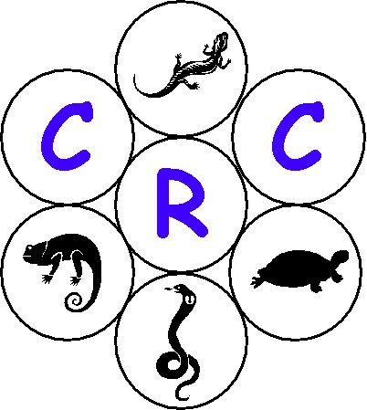
General Meeting – 2004/07/30 (Fairmont High School)

- Opening & Welcome

Tracy Dawson opened the meeting and welcomed all present.

- Amendment to the previous minutes

There where no amendments mentioned to the minutes dated 2004/05/28.

- Introduction and overview

Tracy introduced the agenda for the evening for the and discussed the following items in general:

- She requested that all cell phones to be switched off unless it needs to be left on in case of an emergency.

- She went on to encourage all to go to the CRC’s web site. The web address is as follows: http://www.crc.za.org/

- New recruits/membership for 2004 - Chris De Koker – Membership Secretary (0823236453)

  - Junior Member R 50.00
  - Senior Member R 125.00
  - Family Member R 200.00

- Slide show – Esther van der Westhuizen (Butterfly World)

Tracy introduced Esther who owns Butterfly World in Klapmuts. Esther introduced herself and gave a brief overview of what she has done and how Butterfly World came She then presented a magnificent series of slides on scorpions and spiders. She also had a few specimens available for the audience to see.

Tracy thanked Esther for a very nice and interesting presentation and presented her with a thank you gift.

- Beauty pageants

Tracy announced the beauty pageant. Thanks went to Margo, Greg and Graham who judged the reptiles on show. The following their out come of the show:

Name & Surname | Photo # | Reptile | Comments
Marc Avella | 1, 2 | Spotted Bush Snake | Scarred, but only indig on show. Invited to next show - NC
Chris De Koker | 3, 4 | Boa
Jean Maggott | 5, 6 | Boa | Cleanest Colour on Show.  Invited to next Show - NC
Francois Lourens | 7, 8, 9 | Carpet Pythons | Larger of the two –  Invited to next Show - NC
Luke Naude | 10, 11 | Sinaloan Milk Snakes | Only Milks on the show.  Invited to the next show - NC
Marc Witberg | 12, 13 | Albino Pine Snake
Keane Witberg | 14, 15 | Californian King
Devon Wilson | 16, 17 | Corn Snake | Nor/Het
Gary Keyser | 18, 19 | Xanthic Corn
Ruben Miles | 20, 21 | Corn Snake
Lynne Parker | 22, 23 | Corn Snake | Best on show –  Invite to next meeting – NC
G Lotter | Eie foto’s | Black Corn
G Lotter | Eie foto’s | Miami Corn | Invited to next show - NC
Margo Wilke | 24, 25 | Grey Banded King | Not Part of Competition – Photos only
Margo Wilke | 26, 27 | Sinaloan Milk Snakes | Not Part of Competition – Photos only

Well done to the 6 that went through to the next round of the beauty pageant.

The follow-up on the beauty pageant will be at the 24 September 2004 general meetings. All members are welcome to enter a pet reptile in the CRC Beauty Pageant. Plse be reminded that this competition is only open to CRC members.

Reptiles were judged on the following criteria:

- Health and Physical condition (Reptiles must be healthy and alert, without scars, kinks or defects).
- Beauty and Breeding (a ‘rare’ reptile does not score higher, but a snake should be an excellent example of its breed, with good markings and coloration).
- Temperament (with the breed taken into consideration, reptiles should be handleable, alert but not nervy, confident but calm).

Entry fee: R10 entry fee was per reptile. Winner and runners up will be presented with a framed photograph (taken by a professional) of their reptile and a rosette at the 2004/11/26 meeting.

- General

  - Bumper Sticker Competition

- Winner: Reinhardt Viljoen (My Boa has a crush on you) – 10 Stickers where handed over to him by Marcel Witberg.

- All Club members will receive a bumper sticker in the post.

- Additional bumper stickers are available at R5 each. Please support the club and sell these stickers.

  - Newsletter

- The second newsletter has been distributed to all the members

  - Legislation Meeting

Be advised that we will be having a meeting pertaining to legislation issues surrounding reptiles at Fairmont High School.

Date : Monday 2004/08/23
Venue : Fairmont High School
Time : 18h30

Items that will be discussed are as follows:
1. Template discussion.
2. Priorities the Gray list to date.
3. Establish work groups to do risk assessments.
4. Discussion on questions to be tabled with the WCNCB at the next CRC/WCNCB meeting.

NOTE : This meeting is only open to CRC members only.

- Closure

Pierre closed the meeting and thanked all for attending the meeting.

- Break (Tea/Coffee)

Tracy then introduced the tea and coffee break and thanked all for those involved with this.

- Next General Meeting

Venue : PineHurst (Green School) in Pinelands
Date : 2004/09/24
Time : 19h00

- Committee

Name | Cell # | Email
Pierre Joubert – Chair Person | 0845562007 | ejoubert@mweb.co.za
Gary Keyser – Vice Chair Person | 0828902194 | gary@intabatech.com
Marcel Witberg – Secretary | 0827847314 | witbergm@telkom.co.za
Gary Fryer – Newsletter Editor | 0826394310 | fryer@fairmont.co.za
Zirk MacKay – Legal Advisor | 0824680371 | zirkmackay@mweb.co.za
Deon Van Zyl – Treasurer | 0834446983 | dg_vanzyl@mweb.co.za
Tracy Dawson – Marketing | 0824148292 | may@gin.co.za
Alan Levin – Web Master | 0826008181 | alan@futureperfect.co.za
Francois Lourens – Library | 0835552938 | Flourens@ananzi.co.za
Chris De Koker – Membership Secretary | 0823236453

Welcome from the CRC goes to the 5 new members

