Cape Reptile Club | 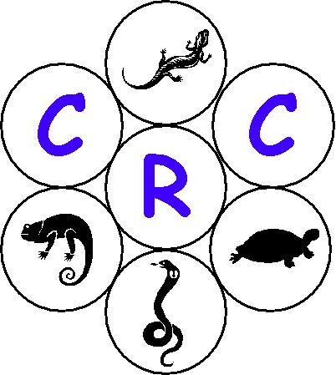
General Meeting – 2003/11/28 (Fairmont High School)

- Opening & Welcome

Tracy opened the meeting and welcomed all present.

- Amendment to the previous minutes

There where no amendments mentioned to the minutes dated 2003/09/26.

- Introduction and overview

Tracy introduced the agenda for the evening and discussed the following items in general:

  - She requested that all cell phones to be switched off

  - Tracy then requested all to keep their containers, with reptiles in, closed and discussed what the amnesty permit was all about.

She then recapped on the provisos as set out by the CNCB, namely:

- All snakes transported must be on a CNCB permit i.e. Transport or captivity permit.
- No reptiles transported to the general meeting may be sold, donated, swapped or offered for sale, donation or swapping or may in any other way be alienated during the general meeting.
- The amnesty does not authorize the transportation of any dangerous (esp venomous) reptiles.
- A register needs to be kept at the meeting of who brought what.

She went on to say that the members need to provide their details regarding the reptiles they brought to the show-and-tell to Marcel as these need to be logged on the register for Nature Conservation.

Tracy then briefly discussed the transmission of diseases from one snake to another due to handling other people’s snakes. Careful husbandry needs to prevail was the closing statement made to this topic.

  - Tracy mentioned that there is quite an assortment of information on the CRC’s website and encouraged the members to go and look at it. The site address is www.crc.za.org

  - Tracy then mentioned that there would be refreshments for all and requested all non-members for a small donation for the refreshments.

- Newsletter Overview

  - Gary gave an overview to the newsletter number 4 that was distributed a week prior to the general meeting.

  - Gary then requested that the members of the club forward any suggestions to the newsletter of what you would like to see. He went on and requested members to make use of the classifieds section which will also be published on the web page.

Gary’s contact details = 0826394310 (fryer@fairmont.co.za)

- Show-and-tell (Club Members)

  - All the club members had a chance to show their snakes. See appendix A.

  - Tracy then requested Shaun MacLeod to give a brief outline of the legalities surrounding Nature Conservation as he was a catch-and-release expert and he was an honoree member of Nature Conservation.

  - Deon Louw made the show-and-tell very interesting as he donated a California King Snake to one of the children who didn’t own a snake. All the child had to do was guess what snake he took out of his bag. He did however add that the child could only get the snake once the transport permits has been acquired.

- Break (Tea/Coffee)

Pierre then introduced the tea and coffee break and thanked all for those involved with this.

- Legislation

  - Due to the lengthy show-and-tell and the lengthy break the legislation was not discussed. Pierre did however suggest with those still present in the hall that there were two options, namely, the committee can give an overview of the CRC/ CNCB meeting held 2003/11/14, which could take quite a while, or to send a copy of the approved minutes to all the club members. Needless to say, option two was selected. See appendix B for the minutes between the CRC and the CNCB.

- Closure

Pierre then closed the meeting and once again thanked all who attended.

- Next General Meeting

Venue : Pine Hurst School, Pinelands
Date : 2004/01/30
Time : 19h00

