Cape Reptile Club | 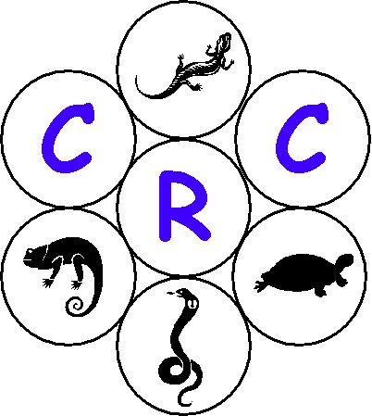
General Meeting – 2003/09/26 (Pinehurst School, Pinelands)

- Opening & Welcome

Pierre opened the meeting and welcomed all present. A special welcome went to Marius Burger.

- Introduction and overview

Tracy introduced the agenda for the evening and discussed the following items in general:

  - She requested that cell phones are switched off

  - Tracy provided feedback wrt the show-and-tell amnesty given to the CRC club members. The following point where highlighted:

- The CNCB has granted amnesty to club members only to bring their snakes to general meetings provided that:
  - All snakes transported must be on a CNCB permit i.e. Transport or captivity permit)
  - No reptiles transported to the general meeting may be sold, donated, swapped or offered for sale, donation or swapping or may in any other way be alienated during the general meeting.
  - The amnesty does not authorize the transportation of any dangerous (esp venomous) reptiles.

- A register needs to be kept at the meeting of who brought what and the following detail needs to be provided by the members bringing the reptile to the show:

Name and Surname | Tel or Cell# | Qty | Common Name | Scientific Name | Permit #

  - Tracy then announced that the CRC’s website was up and running. She requested all to go to the site. The site address is www.crc.za.org

  - The CRC outing to De Vonds was discussed and details wrt the outing were distributed to all. (See appendix A)

- Slide show – Marius Burger

  - Tracy introduced Marius Burger who is a herpetologist. Marius introduced himself and gave a brief overview of what he has done in his life thus far wrt herpetofauna. He then presented a magnificent series of slides from central Africa depicting various herpetofauna that they encountered and describing quite a few of the species.

  - Pierre then thanked Marius for the great show and presented him with a gift of thank.

Marius Burger – sungazer@iafrica.com

- John Spence

  - Pierre handed John his honorary membership to the CRC for the two slide shows he gave to the club as well as for his outstanding work he has achieved in the field of reptiles.

- Newsletter Overview

  - Gary gave an overview to the newsletter number 3 that was distributed a week prior to the general meeting.

  - Gary then requested that the members of the club forward any suggestions to the newsletter of what you would like to see. He went on and requested members to make use of the classifieds section which will also be published on the web page.

Gary’s contact details = 0826394310 (fryer@fairmont.co.za)

- Library Overview

  - Francois handed out a list of books, video’s, brochures and archive material that is available to club members in the CRC’s library. All those interested must feel free to contact him.

Francois’s contact details = 0835552938 (Flourens@ananzi.co.za)

- MTN discussion / proposal

  - Pierre discussed appendix B with all present at the meeting. He mentioned if any additional information is required the the best is to contact Deon van Zyl.

Deon’s contact details = 0834446983 (g_vanzyl@mweb.co.za)

- Membership Overview

  - Pierre mentioned that the club has a membership base of 51.

  - The new members that join at the meeting = 8

Welcome from the CRC goes to the 8 new members

Membership | Total
Affiliated | 7
Family | 9
Honouree | 3
Institution | 2
Junior | 11
Senior | 27
Grand Total | 59

  - Any information regarding membership plse feel free to contact Chris @ 0823236453

- Break (Tea/Coffee)

  - Pierre then introduced the tea and coffee break and thanked all for those that helped in the kitchen, especially Gary and Zirk.

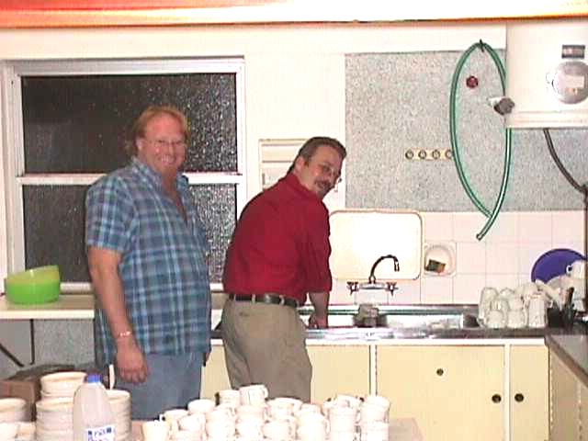

- Show & Tell

  - Tracy then broke away from the general meeting with all those interested in King and Corn snakes. Thanks goes to the following people for providing the snake for the show-and-tell:

- Margo Wilke who provided three corn snakes
- Timothy Clark who provided one corn snake
- Pierre Joubert who provided three king snakes

  - Thanks also goes to Francious who helped Tracy with the show-and-tell and who showed the audience that one should not handle corn snakes before you handle a king snake otherwise you get bitten. The reason for this, corn snakes represent food to the king snakes.

- Legislation

  - Pierre reported that the meeting held with the CRC was a very constructive and purposeful meeting. Margo also mentioned that she felt very positive for the way forward with the CNCB.

See appendix C for the draft minutes of the meeting between the CRC and the CNCB.

  - Pierre then discussed the Strategy document and the way forward wrt the compilation of the black, grey and white list. He requested those that are interested in getting involved with these lists, being it research or data inputs or what ever should contact either him or Margo. Ultimately Gary will be putting the whole proposal together as he has done the framework of the document already.

  - Margo then discussed the Bio Diversity Bill, Ordinance and mentioned that the meetings with the CNCB would take place every two months.

- Closure

Pierre then closed the meeting and once again thanked all who attended.

- Next Meeting

Venue : Fairmont High school
Date : 2003/11/28
Time : 19h00

Appendix A

CLUB OUTING

4 October 2003

Please join us for a morning of fun, food and entertainment at De Vonds Snake Park in Wellington. A light braai lunch (boerewors rolls and cooldrink) will be served, and an indepth tour of the facilities will be on the cards!

De Vonds houses an impressive collection of cobras and elapids, and also houses large constrictors, lizards, monitors, tortoises, adders, vipers…!

Time: 10h00
Date: 4 October 2003
Venue: De Vonds Slang Sentrum

Adults: R20.00 each for members, R35 for non-members
Children: R15.00 each for members, R25 for non-members

Prices include entry, lunch (boerewors rolls and salads) and soft drinks

RSVP before Thursday 2 October to Tracy Dawson on 082 414 8292

Appendix B

Cape Reptile Club
MTN PAKKET – 2003

Geagte klub lib (Lands wyd)

MTN het 'n pakket saamgestel wat voordele aan ingeskrewe klublede bied. Dit is spesiaal vir klublede van herpetologieverenigings regdeur die land. Ons verwag van elke klub om die status van elke aansoeker te bevestig. Hierdie voordele verval natuurlik sodra jou lidmaatskap verval.
Bestaande kontrakte:
Bestaande lede van mtn-sp kan 10% afslag kry op hulle maandelikse rekening. Al wat gebeur is dat mtn-sp 'n kode plaas op jou bestaande pakket. Jy verander dus nie van pakket nie an alles bly dieselfde behalwe vir die afslag. Indien jy die voordeel wil hê, stuur asseblief vir my jou naam en 083-selfoonnommer. Dit is al.
Nuwe kontrakte:
Ingeskrewe klublede kan nuwe kontrakte kry met handstukke teen 'n mededingende prys. ingesluit is die aanbiedinge. Jou normale maandelikse oproepkoste sal ook 10% minder wees.
Indien jy belangstel in 'n pakket, stuur asseblief vir my jou naam, adres en kontakbesonderhede. ek sal jou in kontak bring met mtn-sp sodat julle die kontrak kan sluit.
Deon van zyl
(w )021 422 0996
(s) 083 444 6983

Appendix C

Cape Reptile Club
Committee Meeting – 2003/09/05 (Butterfly World)

- Attendance List
Name | Cell # |  | Email
Pierre Joubert | 0845562007 | CRC | ejoubert@mweb.co.za
Margo Wilke | 0824805077 | CRC | wilke@yebo.co.za
Marcel Witberg | 0827847314 | CRC | witbergm@telkom.co.za
Dr Ernst Baard | 0824140424 | CNCB | baarde@cncjnk.wcape.gov.za
Deon Hignett | 0723913269 | CNCB | Dhignett@pawc.wcape.gov.za
Zirk MacKay | 0824680371 | CRC | zirkmackay@mweb.co.za
Chris De Koker | 0823236453 | CRC
Esther vd Westhuisezen | 875-5628 | CRC | esther@yebo.co.za

Apologies
Name | Cell # |  | Email
Gary Fryer | 0826394310 | CRC | fryer@fairmont.co.za
Guy Palmer | 0824151884 | CNCB | palmerg@cncjnk.wcape.gov.za
Francois Lourense | 0835552938 | CRC | Flourens@ananzi.co.za
Tracy Dawson | 0824148292 | CRC | may@gin.co.za
Deon Van Zyl | 0834446983 | CRC | g_vanzyl@mweb.co.za
Alan Levin | 0826008181 | CRC | alevin@pawc.wcape.gov.za

- Opening & Welcome

Pierre Joubert opened the meeting and welcomed all present. He welcomed Dr Baard and Deon, and thanked them for making the time available to meet with the CRC. He then thanked Esther for providing the venue. Pierre mentioned that we would be working on the expanded agenda and thanked Deon for requesting this. He mentioned that in the future, this would be the format for future agenda’s.

- Previous meeting (2003/05/23) action steps

Marcel mentioned that he would discuss three action steps from the previous minutes, as the rest will be handled further in the meeting.

  - Dr Baard confirmed that the status quo still remains the same, wrt Deon Hignett being the main distributor of information between the CNCB and the CRC.

  - Marcel then mentioned that the CRC is still willing to handle general questions on husbandry etc on behalf of the CNCB wrt herpetofauna but to date have not received any such referrals. Deon acknowledge this and mentioned that he refers quite a few matters to Margo regarding various animals in general.

  - The CRC wanted to know if there was any progress wrt to the electronic sourcing of the name list of permit holders in the Western Cape. Deon responded that this contravenes with private individuals right to privacy. The CRC accepted this, and requested that a flyer of some sort gets attached to permits to promote the CRC. All accepted the request. Marcel to design such a flyer icw Deon Hignett to promote the CRC wrt all permits that get posted by the CNC.

- Strategy Document

  - Pierre facilitated the topic and requested the CNCB to state the status of the Strategy Document. He also wanted to know who would be the policy makers regarding the document, and where would the CRC fit into the process. Pierre then highlighted some of the goals within the Strategy Document and some of the objectives within the CRC’s constitution, and concluded by saying that both parties are striving to achieve the same outcome for herpetofauna in the Western Cape.

  - Both Dr Baard and Deon acknowledged this, and agreed that it is important that both parties work together in achieving the goals and objectives of the Strategy Document and of the CRC’s constitution.

  - Dr Baard then responded by saying that the strategy document is for general information only, and the purpose is to provide a backbone/norm to the conservation of herpetofauna in all the nine provinces within South Africa. He mentioned that, it is a draft document that forms part of the greater picture, namely the Bio Diversity Bill. He also mentioned that the draft policy document would be debated vigorously internally before a final draft policy document is published for public input and debate.

  - The CRC highlighted that parts of the Strategy Document has been implemented already within the Western Cape. The CNCB responded by saying this is true and that the Strategy Document should be regarded as 95% of the carcass of the final draft policy document to be published for public participation. Dr Baard also ensured all present that the CNCB is committed to assured public participation, and both Deon and himself would ensured that the CNCB would make an effort to contact the CRC when this policy document gets published for public participation.

  - It was then mentioned that there are many gray areas within the strategy document that still needs to be addressed. One area of concern is the commercial collecting of herpetofauna from the wild eg. Traditional healers. Another area of concern is that the strategy document mentioned that the transport permits would be abolished and a proof of purchase would be suffice. Deon then agreed that there are still many gray areas that need to be addressed, but told the committee members present that the status quo remains the same until the policy document has been drafted, and the Bio Diversity bill has been accepted by parliament.

  - A general statement was made that it is very important that the CRC gets involved as early as possible wrt the policy making process as there is a wealth of knowledge within the club. The CRC represents the following groups within the herpetofauna community in the Western Cape: Breeder, institutions, traders, vets, catch & release, rehab, affiliations to HAA and other herp clubs and the end buyers (hobbyists). This wealth of knowledge can be used positively to assist the CNCB in achieving its goals, and the CRC in achieving its objectives. Dr Baard agreed with the statement, and mentioned that the CNCB would keep this in mind for any future developments and/or assistance with regards to herpetofauna in the Western Cape.

  - The question was raised on what priorities, if any, have the goals/objectives got within the Strategy document, and is there a rollout plan for the goals/objectives in the Strategy document? The CNCB responded and summed up the way forward by mentioning that the first milestone would be the passing of the Bio Diversity bill. The second priority would then be the drafting of the policy document using the Bio Diversity bill, and the draft strategy documents as source documents. The third major priority will be to get the CRC and public participation with regards to the policy document.

- Black, Grey & White list

  - Pierre started the topic by mentioning that as part of the strategy document and as part of the policy making process, the CRC would like to get involved in the drawing up of the list of unwanted and wanted herpetofauna in the Western Cape. Pierre also requested the CNCB to provide their short-term and long-term processes regarding the list.

  - Dr Baard responded by saying that the short-term process remains the same. There are various criteria that gets used in the scientific approach, namely: Has the species become invasive somewhere in the world, does the species originate from the same climatic variances as in the Cape, does the species originate from the same geographical area as in the Cape, and various other filters are also used.

  - The long-term process was debated in depth. It was mentioned by Dr Baard that there would be a national list of unwanted species to which each province can add additional species. He also mentioned that the list would probably group species of reptile instead of per individual species. It was then agreed upon by both the CNCB and the CRC that starting with a black, gray and white list would be a mammoth task. A starting point that will be adopted would be to start with a list of species that are on permit, which exists in the Western Cape. Added to the list would be the species that is wanted in the Western Cape by herpetofauna lovers. The process will be as follows:

    - Phase 1 - CRC

      - Compile a list A of all the groups of species that exist on permit in the Western Cape.

      - Compile a list B of all the groups of species that is wanted in the Western Cape.

      - The lists need to have the following headers:

Common Name | Scientific Name | Country of Origin | Natural Habitat | Basic Distribution | Remarks

      - The CRC to submit list A and B to the CRC scientific sub-committee. It was also mentioned that the lists would be living documents, meaning that they get revised periodically. The CRC’s sub-committee will recommend their own white, grey and black listing. The sub-committee will then submit the list to the CNCB.

    - Phase 2 – CNCB

      - The CNCB will take this lists and highlight which groups of species will appear on the wanted / unwanted species list. This wanted /unwanted species list would then be returned to the CRC.

      - The CNCB will take this list and highlight which group they are uncertain about. This so-called gray list would then be forwarded to the CRC, with reasons why they appear on this list. The CRC will then accumulate information, from various sources, regarding the specie group and provide the CNCB with a recommendation of either the species should appear on the wanted list or on the unwanted list. It was also decided that before the document goes to the CNCB, that the document gets screened by a “Scientific” sub-committee within the CRC so as to ensure the authenticity and content of the information is of the highest standard. The appointed committee members will select this sub-committee. All agreed to this.

    - Flow chart

<start>

-------> CRC (submit lists of what we have / what we wish to have)

-------> CRC scientific sub-committee (filter lists to produce a black, grey and / or white list)

------> CNC (confirm scientific sub-committee listing and / or re-classify listings)

------> CNC (final list submitted to CRC for distribution )

<end>

  - In conclusion Pierre mentioned that this would be a great start to the long-term process in resolving the issues surrounding the black, white and gray lists. Dr Baard agreed and responded by saying that this would also help the CNCB tremendously. Deon also mentioned that there would also be clear-cut guidelines to assist the CNCB officials in field who are daily checking and issuing permits.

- Bio Diversity Bill

  - The CNCB was asked why the CRC wasn’t informed of the extension given for public participation wrt to the Bio Diversity Bill after the CRC requested, in the previous meeting, to be informed of all process changes regarding herpetofauna. Dr Baard and Deon responded by saying that it was an oversight on their behalf, but reassured that the CNCB would in future inform the CRC of all process changes regarding herpetofauna. The CRC accepted this.

  - Margo requested a copy of the Policy on the Conservation and Sustainable use of Biological Diversity. Dr Baard mentioned that this is the big international convention document and suggested that it gets sourced from the internet. Margo accepted this.

- Ordinance

  - The CRC wanted to know what the status was regarding the CNCB’s Ordinance. Deon responded by saying that Japie Theron is going to be tackling this, and that he would keep the CRC informed on the progress regarding the ordinance.

- Schedule for next meeting

  - Pierre proposed to the CNCB that we meet every alternate month to the general meeting. All agreed and tentatively arranged the next meeting to be held in the last week of October. Marcel will liaise with Dr Baard and Deon to confirm a date.

- Show-and-tell amnesty

  - The CRC requested from the CNCB to grant amnesty to club members who wish to bring their reptiles to the show-and-tell sessions at the general meeting. This was requested to educate the club members and the general public, who attend the general meetings, on various reptiles. Deon agreed to this, and would provide the CRC with a letter to exempt members to have permits for the show-and-tell. Marcel to follow up with Deon. Deon did however stipulate that the following criteria would have to be adhered to:

    - This amnesty is only granted to club members.

    - Snakes being brought to the meeting must be on permit already.

    - A register is kept of the snakes brought to the meeting. The register needs to be forwarded to Deon after every general meeting. The following template will be used:

Name and Surname | Tel or Cell# | Qty | Common Name | Scientific Name | Permit #

- General Issues

  - The CRC thanked and expressed their appreciation to Deon Hignett for the tortoise brochures for distribution to the CRC members to broaden their knowledge wrt tortoises.

  - The CRC mentioned and applauded that the average turnaround time to issue a permit by the CNCB is 3 hours. This was feedback received from one of it’s members.

  - The CRC mentioned that it would like to assist the CNCB with various projects.

  - The CRC also mentioned that the regulation and monitoring of permits in the Western Cape is way ahead of the rest of the provinces and wished to thank all involved.

- Closure

Dr Baard and Deon expressed with great satisfaction the positive process adopted by the CRC with regards to various issues. They also thanked the CRC for the positive feedback received, and mentioned that it is nice to hear the good with the not so good. Dr Baard and Deon then thanked all who attended.

Pierre closed the meeting and thanked all for attending the meeting.

- Next Meeting

Venue : Butterfly World
Date : Last week in October (To be confirmed)
Time : 11h00

Feedback from Dr Ernst Baard – 2003/09/27

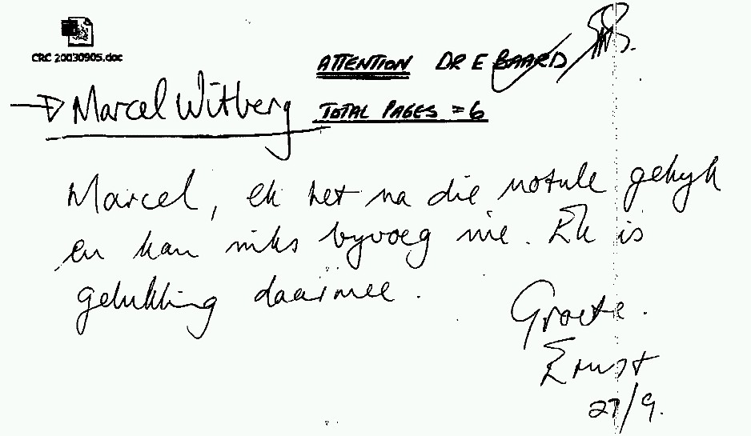

Feedback from Margo Wilke – 2003/09/11

From: Patrick [mailto:wilke@yebo.co.za]
Sent: 11 September 2003 17:18
To: Marcel Witberg (M)
Subject: RE: Urgent : Draft Minutes - 2003/09/05

Hi Marcel

Here are the changes:

Point 4.4 Changed "ensure" to "assured"
Point 4.7 What do these first two lines mean? The sentences don't make sense.
Point 10.1 Deon's surname needs to be "Hignett", not "Higgnet"

Feedback from Pierre Joubert – 2003/09/11

Telephonic feedback – All looks great just check the spelling of Deon’s surname

Feedback from Deon Hignett – 2003/09/12

From: Deon Hignett [mailto:Dhignett@pawc.wcape.gov.za]
Sent: 12 September 2003 10:58
To: baarde@cncjnk.wcape.gov.za; Marcel Witberg (M)
Subject: Re: Draft Minutes - 2003/09/05

Hi Marcel

Thanks for the comprehensive and well written minutes.

I only have one or two very minor tweaks.

1. I would steer clear of becoming too attached to the date "22
September 2003" in para's 4.3 & 4.7. The Bill as it currently stands
has been OK'D by the NCOP, the National Assembly sits during the week of
the 22nd and only thereafter will it go to Parliament for final approval
and eventual promulgation. All things going well and no attempts at
sabotage and being optimistic, we may see the Bill becoming an Act a
week or several thereafter. Emphasis on the word "may".

2. The phases set out in para's 5.3.1 and 5.3.2 doesn't include the
option of a black-list, as discussed. I was under the impression, Ernst
please correct me if I'm wrong, but after the submission of the CRC's
list (basically lists indicating "what you have" and "what you'd like to
have") to CNC, we would lump the taxa from your lists(s) into respective
black, white or grey lists. This black, white and grey list would then
be supplied to the CRC for distribution to its members. Most
importantly, your INITIAL lists would be submitted to us VIA your
"scientific sub-commitee", who will attach a listing recommendation of
their own (i.e. black, white or grey) to each species. As a rather
shoddy flow-chart, this how I understood the flow of information would
be:

<start> CRC (submit lists of what we have / what we wish to have)
-------> CRC scientific sub-commitee (filter lists to produce a black,
grey and / or white list) ------> CNC (confirm scientific sub-commitee
listing and / or re-classify listings) ------> CRC (final list submitted
to CRC for distribution )<end>

3. Under para 9.10, I think that it should also be made clear that this
exemption is for TRANSPORT only. No sale, donating, swapping, lending,
borrowing or in any other way alienating of animals will be allowed or
is implied with such an exemption. Under the same para, I also think
that your template should also include columns for "address from/to" and
"captivity/transport permit No.". Although I don't want to dictate to
people what they should be allowed to show and tell-about, but I really
think that the exemption should be for non-venomous snakes only. I'm
sure that there's a lot of eager beavers out there who just can't wait
to show off their latest hotty to their buddies but I don't think that
this should be the time or place. What do you think? I note that you
have already applied for this exemption letter but before I process it
further, I just want to clarify these fore-mentioned issues. Also could
I get the full physical details of where the next CRC meeting is to be
and also, if possible, the latest list of all CRC members, to whom the
exemption will apply.

Well, that's my 3 cents worth.

Cheers

Deon

Deon L. Hignett
Fauna, Flora, CITES & Hunting
Western Cape Nature Conservation Board
Private Bag X100, Cape Town, South Africa 8000

e-mail: dhignett@pawc.wcape.gov.za
Tel: +27 (0)21 - 483 3539
Fax: +27 (0)21 - 483 4158
URL: http://www.capenature.org.za

-----Original Message-----
From: Marcel Witberg (M)
Sent: 29 September 2003 10:15
To: 'Deon Hignett'
Cc: Marcel Witberg (M)
Subject: Draft Minutes - 2003/09/05

Hi Deon

Just some feedback from your mail below:

1. This has been amended within the minutes as requested.
2. I have amended the flow as per the attached.
3. Thanks for the show and tell permit for the 26th of September 2003.
At our committee meeting held 2003/09/12 the following was decided:
1. No venomous snakes will be allowed at the general meetings. (Thanks for your input).
2. The show-and-tell criteria's will be announced at the general meeting on the 26th.
3. Margo and Pierre will use this permit.
4. Gary will publish the show-and-tell criteria's in the next newsletter and will also do a part on the humane side of treating your reptile.

Attached find the final draft for your approval

Regards
Marcel

