Cape Reptile Club | 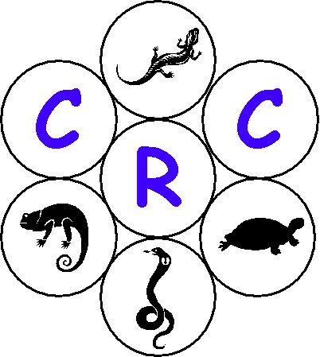
General Meeting – 2003/07/25 (Fairmont High School)

- Opening & Welcome

Tracy opened the meeting and welcomed all present. A special welcome went to John Spence from Tygerberg Zoo.

- Introduction

Pierre mentioned that it is nice to see so many new faces at the meeting and hopes that it will escalate for here on. He then briefly went through the agenda and mentioned that the next meeting will be held in the South on the 26th of September 2003.

Next meeting details

Date : 2003/09/26
Time : 19h00

Venue : Pine Hurst Jnr School (Green School)
Pinelands

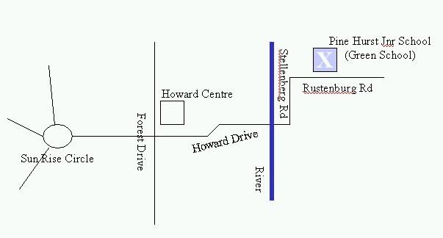

- Snake Slide Show

- John Spence from the Tygerberg Zoo gave a very interesting and a very informative slide show regarding snakes that can be found in South Africa. The emphasis was on the identification, which was extremely interesting.

- On show were two skeletons of snakes, namely the skeleton of a Cobra and a skeleton of a Puff Adder.

- Pierre then handed over a gift to John and thanked him for the interesting show. It was also mentioned that the committee should look into a proposal made by one of the members to have John as an honorary member of the CRC.
- General

- It was mentioned by Pierre that the membership fees from now until the end of the 2004/03/31 is half price.

- Tea Break

- Show and Tell

- Tracy took all the interested parties to go and look at the various species of snakes that are kept at Fairmont High School. She also handed out a one-pager with questions on how to care for your Burmese Python.

- CRC Involvement with Legislation

- Margo spoke about various issues around various initiatives regarding the involvement of the CRC in legislation. She then pointed out the flow of various main documentation pertaining to the legislation, namely The Bio Diversity Bill, The Strategy document and then the Black list.

  - Strategy Document on Reptiles

Margo reported that it is very difficult to provide comments on the strategy document, as it is quite a comprehensive document. What the committee is busy doing is to find out why certain issues haven’t been implemented in the Western Region as laid down in the document. In addition to this the CRC would also like to get involved with research projects and assist CNCB where they can. The time lines for completion of the document will be discussed at the next committee meeting.

  - Black/Grey/White list

Margo mentioned that she got an telephonic list from Deon Hignett as follows:

    - Stink pot mud turtle
    - Red Slider
    - All exotic terrapins
    - All Lizards inc.
      - Gecko’s
      - Chameleons
      - Basilisks
      - Iguana’s
    - Tarantula Spiders
    - Ferrets

It was then mentioned that a letter is to be drafted to CNCB requesting a formal black list, as suggested by Deon Louw. This letter needs to request the black list from CNCB and if no black list exists then the CRC requests a time line for when such a list will be made available. It must also state that the assumption will be made that if it is not on the black list then it is allowed in captivity in the Western Cape.

Once the CRC has received a list from the CNCB, a final proposal from the CRC will be drafted. The document needs to outline that if the CNCB doesn’t agree with the document then they should highlight the discrepancies. These discrepancies will then be dealt with by the CRC and the CNCB. A compromise with the CNCB can thus be negotiated, so as to have one document on the table that both the CRC and the CNCB agree on.

  - Next Meeting with the CNCB - Tentative

Pierre reported that the next meeting with the CNCB will be 2003/08/29. It was also mentioned that other members from CNC, other than Dr Baard, will be invited.

Proposed points on the agenda will be as follows:

- Previous minutes action steps
- Black, Grey and white list
- Strategy Document
- Bio Diversity Bill
- Ordinance
- Schedule for meetings
- Show and tell amnesty
- Any general issues

- Closure

Pierre closed the meeting and thanked all for attending the meeting.

- Next General Meeting

Venue : Pine Hurst Jnr School (Green School)
Date : 2003/09/26
Time : 19h00

