Cape Reptile Club |  |  | 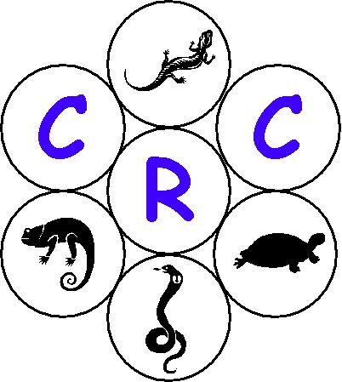
Chair person  Pierre Joubert  084 5562 007  ejoubert@mweb.co.za | Vice Chair Person  Margo Wilke  082 480 5077  wilke@yebo.co.za | Postal Address  P.O.Box 230  Kuilsrivier  7579

30 May 2003

CRC: General Meeting

- Welcome and Introduction

Gary opened the meeting and welcomed everybody present.

He then briefly gave a run down, for those that attended for the first time, on how the CRC was formed.

Gary mentioned that there is the CRC’s constitution available for those that wanted from Marcel. Thanks also went to Caron Da Costa for making these copies of the constitution for the meeting.

He then went on and thanked Margo for arranging the venue.

Gary introduced the following agenda:
• Opening - Gary
• Reptile Show - Mike
• Dr Oakley - Pierre
• Dr Smith - Pierre
• Tea / Coffee
• CRC Involvement with legislation - Margo
• Closure - Tracy

- Snake Show

Mike Johnson gave an excellent snake show for all present. The show included a Molesnake, a Puff Adder, a Cape Cobra, a Boom Snake, a Blue Tongue Skink, a Bullfrog, an Iguana and a nice big Burmese python.

Tracy thanked Mike after the show on behalf of the committee, the members and the visitors.

- Dr John Oakley

Pierre introduced Dr Oakley who is a vet from Fishoek. Dr Oakley briefly discussed his background with reptiles. Pierre then thanked him and handed him his honorary membership to the CRC.

- Dr Steven Smith

Pierre introduced Dr Smith who is a vet from Kenridge, Durbanville. Dr Smith also briefly discussed his background wrt reptiles. Pierre then thanked him and handed him his honorary membership to the CRC.

Pierre mentioned that it is nice to have these two well-qualified Dr’s as part of the club’s membership and as an added bonus, the one practices in the Southern suburbs and the other practices in the Northern suburbs.

- Tea and Coffee Break

Tracy introduced the tea and coffee break and thanked all for those that helped in the kitchen, especially Patrick Wilke.

- CRC involvement with legislation

Margo opened this discussion by telling all of the meeting held between the CRC and Dr Baard from the Cape Nature Conservation Board (CNCB). She then outlined how the Bio Diversity Bill, Government Strategy Document on reptiles and the Black list fitted into each other, and how the CRC is going to be involved in providing the Department of Environmental Affairs and Tourism (DEAT) and the CNCB with input into the compilation of the black, gray and white lists.

Attached, as appendix A, are the minutes of the meeting held between the CRC and the CNCB.

A question was then asked: What would the basis, to work from, be to start working on the list? Pierre and Margo both responded by stating that a list from the CNCB and a list provided to DEAT by the Transvaal Herpetological Association (THA) would be used as a foundation for the compilation of the list of unwanted species. Margo then went on to say that if required, consultants / lawyers on Environmental affairs would be asked for assistance. She also requested the following from the members:

- Members to report any communications found on web sites, government printers regarding the list and/or any press releases related to the list, to please forward this to the committee.

- Members to forward any studies done on species in captivity that can justify their existence in captivity and not become invasive in the wild.

- Members to forward any information and / or points gathered that would assist with the process. Please also remember to specify the source of the information, website addresses, dates etc.

- Members to forward any information on herpetofauna that has become invasive outside its natural habitat, especially in South Africa.

Pierre then mentioned that this would be a formulized process with the CNCB where all meetings will be minuted and all processes will be documented. The members then raised a concern, that the CNCB is disorganized within it’s own ranks and to get processes changed could become a mammoth task. Pierre acknowledged this, but highlighted that a formalized process should and would bear fruit. An informal process would only spell disaster, as nothing would be documented and a bad relationship between the CRC and the CNCB would only cause friction and nothing would be forth-coming. Most members agreed.

Margo then concluded by saying that the following still needs to be actioned with the CNCB:

- The Strategy document would still need to be actioned. An example of which would be the abolishment of transport permits within the region as stated in the document but not yet implemented by the CNCB.

- The Nature Conservation Ordinance is going to be looked at and possibly re-written.

- Closure

Tracy closed the meeting and thanked all for attending the meeting.

- Next General Meeting

Venue : Fairmont High School
Date : 2003/07/25
Time : 19h00

Appendix A

23 May 2003

- Attendance List

Name |  | Cell # | Email
Pierre Joubert | CRC : Chair | 0845562007 | ejoubert@mweb.co.za
Margo Wilke | CRC : Vice Chair | 0824805077 | wilke@yebo.co.za
Dr Ernst Baard | WCNCB : Scientific Services | 0824140424 | baarde@cncjnk.wcape.gov.za
Marcel Witberg | CRC : Secretary | 0827847314 | witbergm@telkom.co.za
Zirk MacKay | CRC : Legal Advisor | 0824680371 | zirkmackay@mweb.co.za
Alan Levin | CRC : Web Master | 0826008181 | alevin@pawc.wcape.gov.za
Chris De Koker | CRC : Membership Secretary | 0823236453

Date : 2003/05/23
Venue : Margo Wilke's house - 4 Linden Way, Pinelands.
Time : 11h00 to 13h00

- Opening & Welcome

Pierre Joubert opened the meeting and welcomed all present. A special welcome went to Dr Baard for taking the time to meet with the CRC’s committee, and this interest shown by the WCNCB is much appreciated. Pierre also thanked Margo for making her house available for this meeting.

Dr Baard responded by mentioning that this meeting is the right step taken in the right direction, which could only bring about a healthy understanding between the CRC and the WCNCB. He also mentioned that he is glad that the club has been established, as this could bring about a win win situation for both parties.

- What does the WCNCB expect from the CRC

The WCNCB expects the CRC to understand that the WCNCB falls within admin structures and ordinances, which are subject to National law that they need to follow. It was also mentioned by Dr Baard that the permit system falls within the managing structure of the WCNCB, and not the policy making structure. The managing structure is there to exert a degree of orders to keep some control. It was mentioned that this is a separate issue that needs to be taken up with Deon Hignett, as it doesn’t fall within the framework of this meeting.

Dr Baard also mentioned that he personally feels that this forum is great, as long as it stimulates order, debate and communication between the CRC and the WCNCB, so that solutions can be found for various issues, problems, policies etc.

Dr Baard also mentioned that once there is order, healthy debate, and a formal communication channel, a future spin off could be that the WCNCB could delegate certain functions to the club.

- Communication channels between the WCNCB and the CRC / WCNCB structure (DAT Down) – Policy structure

Dr Baard started off by giving us an outline of the structure within the WCNCB. This is shown in the diagram below.

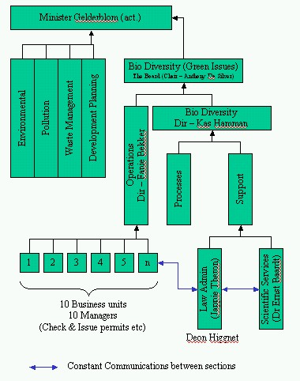
He then continued to mention that the WCNCB falls within the public sector, and things take time to process, due to all the red tape involved.

The question was asked: What would be the best communication channel to be used when the CRC is dealing with CNC and vice versa? Through much debate it was decided that,

- Deon Hignett needs to be the sole keeper of all CRC documentation that flows in and out WCNCB from and to the CRC. All correspondence will also be forwarded to Dr Baard, keeping in mind that Deon will be the distributor of this information within the WCNCB. Dr Baard was requested to speak to Deon and Japie in this regard, and to report back to the chair of the club.
- All documentation leaving the CRC to WCNCB would go through the chair of the club.
- Dr Baard will also inform Deon and any other role-players within WCNCB, that the CRC committee will assist as far as possible, to resolve questions asked by the CRC members and / or the public. This means that the WCNCB will divert general questions such as “Why does my Brown House snake not want to eat” etc. to the CRC. Members will soon get the message that they must first try and get answers from the CRC before they go to WCNCB. In future this could aid the WCNCB to deal with greater herpetofauna issues, and not with general or husbandry issues.

The CRC communication channel is as follows:

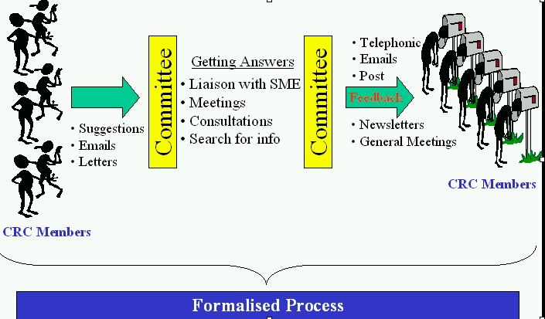

- Name list of permit holders from the WCNCB

Pierre started off by informing all that Deon responded positively in saying that the he hasn’t got the manpower to extract a name list of permit holders for the CRC. It was then mentioned that it is important for the CRC to get this name list, so that we can use it to market the club for sourcing more members. It was then suggested that the CRC will be more than willing to get CRC members to assist in the retrieval of the names of permit holders. Dr Baard will take this up with Deon and Japie, and report back to the chair of the club.

Zirk asked the following question: What is the appeal procedure if permits get rejected? Why it was rejected? At what level it was rejected? – Dr Baard mentioned that the WCNCB falls within the public sector, thus they have an obligation as stipulated by law, to provide the reasons why the application was rejected.

Zirk then asked the following question: What method gets used to accept or reject applications? Dr Baard responded by saying that there is a ‘status quo list’ of unwanted species that gets used for clear-cut decisions by the Law Admin leg. If there is some doubt, the Law Admin section forwards these requested to the Scientific Service section to provide input on the application. They also request input from the Operations business units. The ‘status quo list’ was set up quite some time back, using inputs from scientific research of these species, and through other inputs from various sources. Various criteria were used, such as the geographical area of origin, the life history of these species, and the climate just to mention a few.

Dr Baard, speaking under correction, informed the committee members present that the issuing of permits (excl. transport permits) have an approximate turn around time of about 6 weeks. This, however, needs to be confirmed with Deon Hignett.

- The Black, Grey and white list

Dr Baard first gave the committee some background on the origin of the Government Strategy document on Reptiles that originates from DEAT. He also said that he would try and source the strategy document electronically, and forward it to Marcel, who in turn will distribute it to all in the committee. If Dr Baard can’t source the document electronically, he will fax a copy to Marcel for distribution.

This strategy document came about due to a need identified by Dr Baard. This document was to be drafted by DEAT, to be used as a guideline by the nine provinces, thus trying to set a national norm. Three main steps was followed in the drafting of this document, namely:

- The first step towards this process was that DEAT and the nine provinces got around a table and documented a draft proposal of this strategy.
- As the second step in the process, DEAT arranged a national workshop in Pretoria with all interested parties e.g. Sellers, traders, breeders, SPCA etc.
- The third and final step was the drafting of the first strategy document for reptiles. The nine provinces and DEAT are now using this document as the main guideline document in decision-making processes and in drafting local legislation on reptiles.

Alan asked Dr Baard what status this document has. Dr Baard replied by saying he is not sure if it has green or white status, but he will find out from DEAT, and report back to the chair of the club.

Dr Baard said that the main aim of the list is to ensure that no herpetafauna becomes invasive in South Africa and in the Western Cape. He enlightened all by describing the three barriers that a species has to go through before it becomes invasive. These three barriers are the geographical barrier (species getting into the area from other areas), the environmental barrier (species establishing itself in the environment), and the reproductive barrier (invasive species starting to reproduce in our environment).

Dr Baard mentioned that the WCNCB received a list from DEAT, which reflected the species already in circulation in Transvaal. This list was compiled by THA. Dr Baard then stressed that there is no black list documented for the Western Cape yet. He did however mention that a list of unwanted species is being used as a status quo list at the moment. Pierre will source this list from Deon so that the CRC can use this document to assist in the process of drafting the final black list. The CRC will thus table a proposed list to Dr Baard and Deon Hignett. Dr Baard also said that he welcomed the CRC’s suggestion to get involved in the process for compiling the list of unwanted species. All accepted this. The process for the Western Cape was roughly outlined as follows:

WCNCB (Scientific research)
DEAT (Process for List) Final Document
CRC (Captivity research)

Eventually, as previously discussed, there will be one National black list. However, any of the provinces may add to the list, with public involvement for the protection of the Bio Diversity within that region. Dr Baard then ensured all present, that the WCNCB would keep the CRC informed of all issues arising with regard to the black list.

- Any future plans regarding reptiles

The committee requested that Dr Baard and Deon Hignett keep the CRC informed of all process changes regarding herpetofauna. The committee also requested that the CRC gets involved with these processes, and provide input prior to it going public. Dr Baard agreed and mentioned that they are going to be looking at the total re-write of the ordinance. He will speak to Deon and Japie and report back to the chair of the club.

In the interim the CRC will start looking at the ordinance, and forward suggestions and input to the WCNCB via the chair. Pierre will follow this up, and all agreed.

- Any general reptile issues

Margo raised a concern that the WCNCB takes their time to respond after problems have been identified and reported to them. Dr Baard responded that issues that have been identified and scrutinised, needs to be sent directly to the CEO’s office of the WCNCB.

- General

Dr Baard mentioned that this was a great starting point, and a meeting like this needs to be held quarterly between the CRC and the WCNCB, to stimulate a healthy relationship. All agreed. It was also mentioned that Deon Hignett needs to be invited to the next meeting, as his input is imperative to the process. Marcel will ensure that he gets invited.

- Closure

Pierre closed the meeting and thanked all for attending the meeting.

- Abbreviations used

CRC - Cape Reptile Club
WCNCB - Cape Nature Conservation Board
DEAT - Department of Environment and Tourism
THA - Transvaal Herpelogical Association

- Minutes approved by

Pierre Jouberg : Chair of the CRC : 2003/05/26
Dr Ernst Baard : Head off Scientific services CNCB : 2003/06/09

From: Ernst Baard [mailto:baarde@cncjnk.wcape.gov.za]
Sent: 09 June 2003 13:53
To: Marcel Witberg (M); ejoubert@mweb.co.za
Cc: Deon Hignett
Subject: RE: Draft Minutes 2003/05/23

Marcel
Hiermee die notule met 'n paar korreksies. Mens kan die bewoording hier en daar verkort en "tweak" maar ongelukkig loop my tyd uit. Andersins is ek gelukkig met die notule. Ek hoop ons het intussen al 'n paar van die dinge aangespreek, maar ons kan altyd op 'n volgende keer dit verder neem. Groete en nogmaals dankie vir die uitnodiging.
Groete
Ernst

- Email from Dr Ernst Baard to Deon Hignett

From : Ernst Baard
Sent : 26 May 2003 09:44
To : Deon Hignett
Cc : Pierre Joubert; Marcel Witberg; Fanie Bekker;
Kas Hamman
Subject : Meeting with Cape Reptile Club

Beste Deon

Ek het op Vrydag 23 Mei 'n baie geslaagde en sinvolle vergadering met die Cape Reptile Club bestuur gehad. Die vergadering is by Margot Wilke se woning gehou, en is benewens myself, bygewoon deur die voorsitter, Pierre Joubert, Margot Wilke, Marcel Witberg, Allan Levin, Zirk (kan nie sy van onthou nie) en Chris (kan ook nie sy van onthou nie). Die vergadering was grootendeels 'n eerste poging om beter kommunikasie tussen die Raad en die Klub te vestig, nadat ek my vroeër bereid verklaar het om met die bestuur in gesprek te tree. Dit was baie insiggewend om met die bestuur oor 'n hele aantal aspekte te gesels en debatteer. Marcel het onderneem om die notule van die vergadering op te skryf en te sirkuleer. Ek het onderneem om die volgende punte op te neem:

- The meeting suggested that we establish an open communications channel between the Club and the Board and that it will take the form of preferably written or emailed correspondence and the odd phone call when necessary. When administrative issues are discussed, it will be mainly between the CRC chairperson and/or secretary and yourself as the two main entry points for both organisations. If it is about more policy-related issues, I would be copied in on the correspondence. I would appreciate your comment on this.

- The CRC requested a name list of all persons currently in possession of reptile permits from the Board, in order mainly to do some marketing. Question: are we as public entity allowed to do this or what does the law say? I explained to the CRC that generating this list would take some effort and time, and they offered help in this regard, should this be allowed.

- After explaining that we are just about to start with the review process of the Ordinnance, the CRC indicated that they would like to provide some input into the process, preferably prior to the publication of a "draft for public input". I would appreciate Law Admin's comments on this.

- I conveyed my appreciation towards the Club for an organised approach to reptile matters in the Western Cape, and the meeting suggested a quarterly meeting to discuss and debate issues of mutual concern. I would appreciate your comments on this. Would you be prepared to meet at this frequency?

Groete
Ernst Baard
=====================================================
Dr Ernst HW Baard : Manager: Scientific Services
Cape Nature Conservation
Private Bag 5014 : 7599 STELLENBOSCH
Tel: +27-21-866 1570 or 866-1563/4/5 (wait for dialing tone, then dial
extention 225) : Fax: +27-21-866 1523 : Mobile: 082-41 40 424
Visit our website: www.capenature.org.za
=====================================================

