Cape Reptile Club | 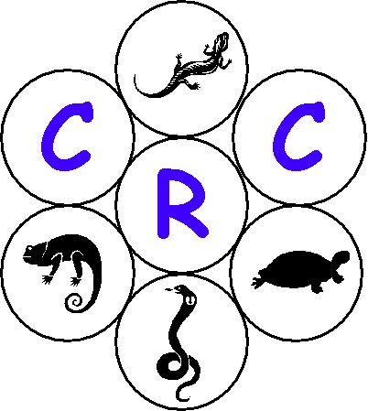
General Meeting – 2002/09/27 (Fairmont High School)

- Welcome and Introduction

Gary opened the meeting and welcomed everybody present. Special thanks went to Deon Hignett from the CNC for attending the meeting. Gary then gave a brief outline of the agenda.

- The constitution

Marcel gave a slide show on the changes wrt the draft constitution. Nobody objected to the changes so these have been accepted in the constitution. Marcel also mentioned that there are still issues to be resolved. These will be highlighted at the next general meeting.

- Club name

Tracy mentioned that the club name would be the Cape Reptile Club, after the last general meetings overwhelming response to the name. Tracy also re-emphasized the aim of the CRC namely:

“The Club aims to be an educational and conservational group of amateurs and professional herpetologists who want to share their knowledge, enthusiasm and friendship with others interested in these fascinating creatures.”

- Newsletter

Gary gave a brief outline on the content of the newsletter tabled at the meeting and mentioned that he has still not received any entries for the classified section of the newsletter.

- Cheetah outreach program

Shaun MacLeod excused himself from the meeting as he was attending to business in Johannesburg. Pierre then gave an overview of the Cheetah outreach program and briefly mentioned possible benefits for the CRC. All seemed very enthusiastic about this.

- Logo competition

Pierre finalized the logo competition and the members of the club chose a logo. Pierre also mentioned to all present and voting to keep the following in mind:

- when the logo is reduced in size will it still be legible
- if copies are made will the logo look great in black and white
- interim committee members are also taking part as they are only interim and it was totally anonymous

Tea & Coffee was served and the members voted. Pierre then handed over the prize to M Witberg, the winner, as voted by the members.

- Permits

Deon Hignett from Cape Nature Conservation gave a brief talk on the various permits you could encounter and why, where, how and when you should obtain these permits.

- Closure of meeting

Tracy closed the meeting and thanked all for making an effort to attend. Gary then put on a video, the Deadly Dozen, for all who where interested. Only the first half of the video was shown as the second half was kept for the next meeting.

- Next Committee meeting

Venue : Fairmont High School
Date : 01 November 2002
Time : 19h00

- Next General Meeting

Venue : Fairmont High School
Date : 29 November 2002
Time : 19h00

